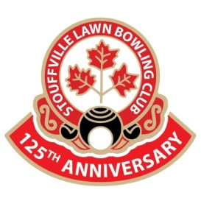 THE SLBC INFORMER
August 2023
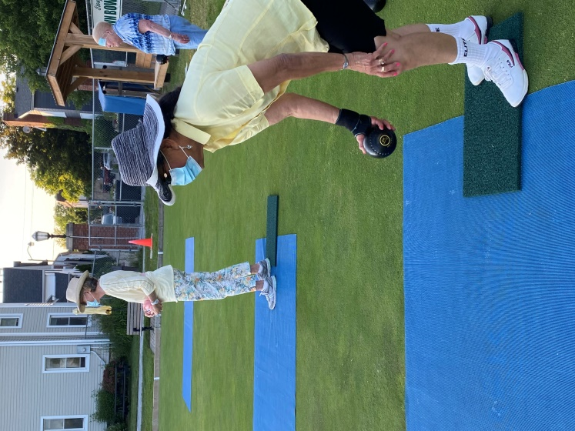
President’s message
As we approach the month of August, there are still many events that may be of interest to you. Our events are always an opportunity to socialize and develop new friendships at the club Our club members are always friendly and approachable and willing to share a story or give advice if asked. I have received many helpful suggestions over the years from club members. (George shared the secret on how to make good perogies). If you have not joined in yet, please come out during August or September and join the fun.
Club News
- League Results
Monday Night winners: Marg Curtis, Tim Thomson and Lynn Raithby
Tuesday Morning winners: Val Innes and Bev Kindness
Wednesday Night winners: Bob Penner and Kris Savage
Congratulations to you all!!
- New Shed
The club has purchased a new 10 by 6 shed to be placed at the back of the property to house the rakes. We are now waiting for the Town to install on the property as they volunteered to construct it.
- Banquet has been booked for Wednesday September 27th at Mill Run Golf Course. Tickets will be on sale starting Tuesday August 8th. Pat, Mary, Pam and Tricia will be selling tickets during league times. If you do not belong to a league or are just on the rover list please email me and I will bring you your tickets. Please come out to enjoy a served dinner at a lovely venue at a reasonable price.-chicken or vegetarian $35 and New York steak-medium $40 per member. Social member and guests $45 and $50 respectively.
August Events
Sunday July 30th, 2023-Ballantrae Summer Games begin
The community of Ballantrae bowlers have arrived for their 4 days (July 30, 31, August 2, 3) of friendly competition. The 5 condominium corporations battle it out for bragging rights. Why not drop by the club and cheer them on July 30 at 1.30, July 31 at 9am, Aug.2 at 9am and Aug 3 at 9am

Friday August 11th, 2023 Mayor’s office All Night Lawn #3 starts 6.30pm till 10.30pm
So far, we have had two great events in partnership with Mayor Iain Lovatt and his executive assistant Brandi. They are back for a third and final event to fundraise for Markham Hospital Foundation. We need volunteers again to assist participants on the greens. It is always a super evening and just as much fun for the volunteers as the participants. Mary has posted a volunteer list in the clubhouse, which is quickly filling up.
If you know someone/group that maybe interested in participating, they can sign up at Allnightlawn.ca, at a cost of $25 per person. Like the previous event, there will be a DJ (disco!!), snacks and bar at the event.
Saturday August 12, 2023, Ron Schell/Murray Redshaw Memorial Tournament (IN-CLUB)
This tournament is now an in-club tournament. Our sponsor, Schell Lumber, as most of you know is located in town close to the club. Ron Schell’s son Kyle is now running the business and has graciously sponsored the club $300 for the tournament. Murray Redshaw was a valued employee of Schell Lumber and an avid lawn bowler. Let’s keep the tournament going and join in the fun. We will be playing 2-8 end games with lunch in between games. The cost is $10.
Sign up in the clubhouse
Tuesday August 15th, 2023 Bowl & Dine starts 6.00pm
Our fourth bowl & dine of the season is being hosted by Darrell & Terri Gibbons and Steve & Kris Savage. The signup sheet in the clubhouse is filling up fast. These convenors are a blast and I am sure the event will be great. Cost for the event is $15 and they will be doing BBQ and of course bowling after dinner. Don’t miss out, come join in the fun!
Friday August 18th, 2023 The Living Assistance Tournament 9.30am
This tournament is full (16 teams). We have 13 teams from Pickering, Campbellford,Stayner, Brampton, Beeton, Lyndsey joining 3 teams from Stouffville in a friendly but competitive show down. The tournament is mixed pairs with lady skipping the team. Thanks to all who have signed up. Feel free to come watch the competition quietly on the porch sipping a cold drink.
Saturday August 19 & 20th, District 11 trebles playdowns
Tentative at the moment as it depends on enrolment of District 11 clubs. The club has offered to host this event. Contact Elaine Stevenson or Bill McCollam of this club for more information if you wish to enter a team of three (open).
Saturday August 26th-The Saturday morning Smile Fours
Bob Stover and company are looking for club members to submit a team of 4 for a friendly competition of fours on this Saturday morning. Find your team and you may have bragging rights for the best foursome in the club. Signup sheet in the clubhouse.
BOWLER PROFILE
Manu Panchal joined our club in 2017. He is a very active member of our club who participates in many of the club’s events, that is if he is not away enjoying travelling with his family or playing sports with his grandson. He also helps on the green on Saturday morning with the SMILE league. He always shows up early to setup the greens at an event and lend a hand were needed. He is soft spoken, good natured, friendly and a pretty good bowler to. You will see his name on our club trophies. Thanks for being part of the club Manu! We are fortunate to have your friendship.
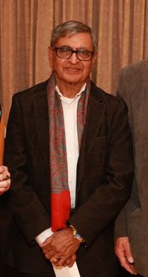

For Sale
- Coin flippers-start your game with a flip of the coin $1.00 each
- Grippo- for sale for $15 per tube ( ask an executive for it)
- 2023 Rule books- for sale $13.55 each
Housekeeping reminders
- Please ensure your rake is safely placed back on the end of the deck after your game and any equipment including water bottle and club towel are returned to where you got them
- If you are closing the club, please ensure all 3 doors to the clubhouse are shut when you leave and that the porch ,greens overhead flood lights and all interior clubhouse lights are OFF.
- Remember to use a porcelain mug rather than plastic or foam cup and place in the sink for washing
Cheers Pam

