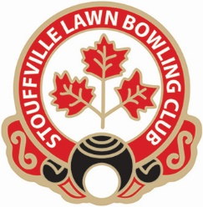
STOUFFVILLE LAWN BOWLING CLUB (SLBC)
2024 REGISTRATION

Last Name: ________________________ First Name: _______________
Address: ______________________ Town_____________________
Postal Code: ____________ Telephone: _________________(Home)( Cell)
_{please note which.}
E-mail address: _________________________
Date of Birth_______________ (required for OLBA registration and insurance coverage)
Female ( ) Male ( ) Non Binary ( ) _{please note which}

Years of lawn bowling experience? _________ Do you consent to having your photograph used for publicity purposes. □ Yes □ No

EMERGENCY CONTACT INFORMATION

Last Name: _________________________ First Name: ____________________
Address: _______________________________ Town____________________
Postal Code: _____________________ Telephone: _____________
E-mail address: _________________________ Relationship to you:___________
WIFE/HUSBAND/DAUGHTER/SON/BROTHER/SISTER /PARTNER
NOTE; SLBC Harassment Policy is posted on club bulletin board
THIS YEAR CLUB BOWLS WILL BE AVAILABLE FOR MEMBERS (PRIORITY TO NEW BOWLERS) ON A FIRST COME BASIS AT NO CHARGE.
Paid: Club Fee Amount: $___________ returning $140, new $120 ,junior $50, social $20

□ Cash □ Cheque #: ______

OLBA Permanent Membership Number: ________________
(SLBC USE)

