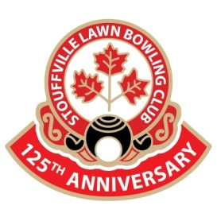 THE SLBC INFORMER
Spring 2024
INTRODUCING THE 2024 EXECUTIVE
 | 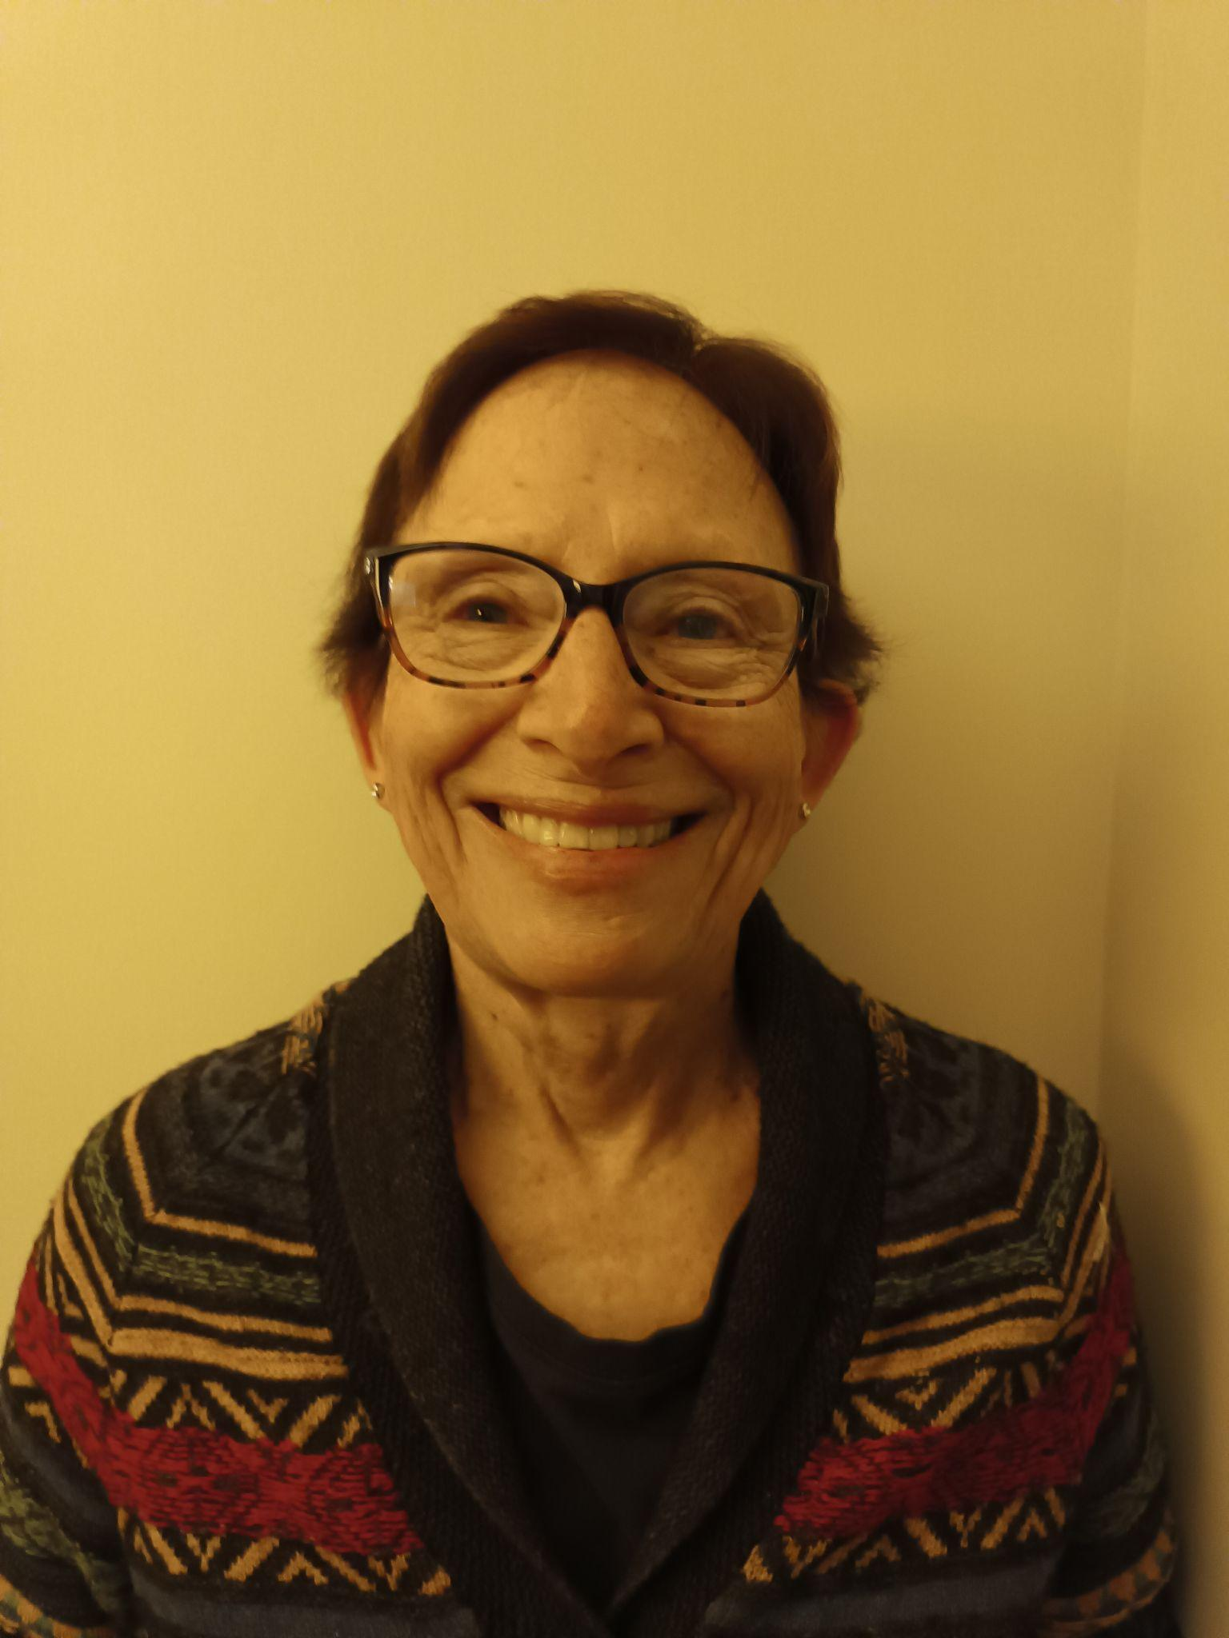 | 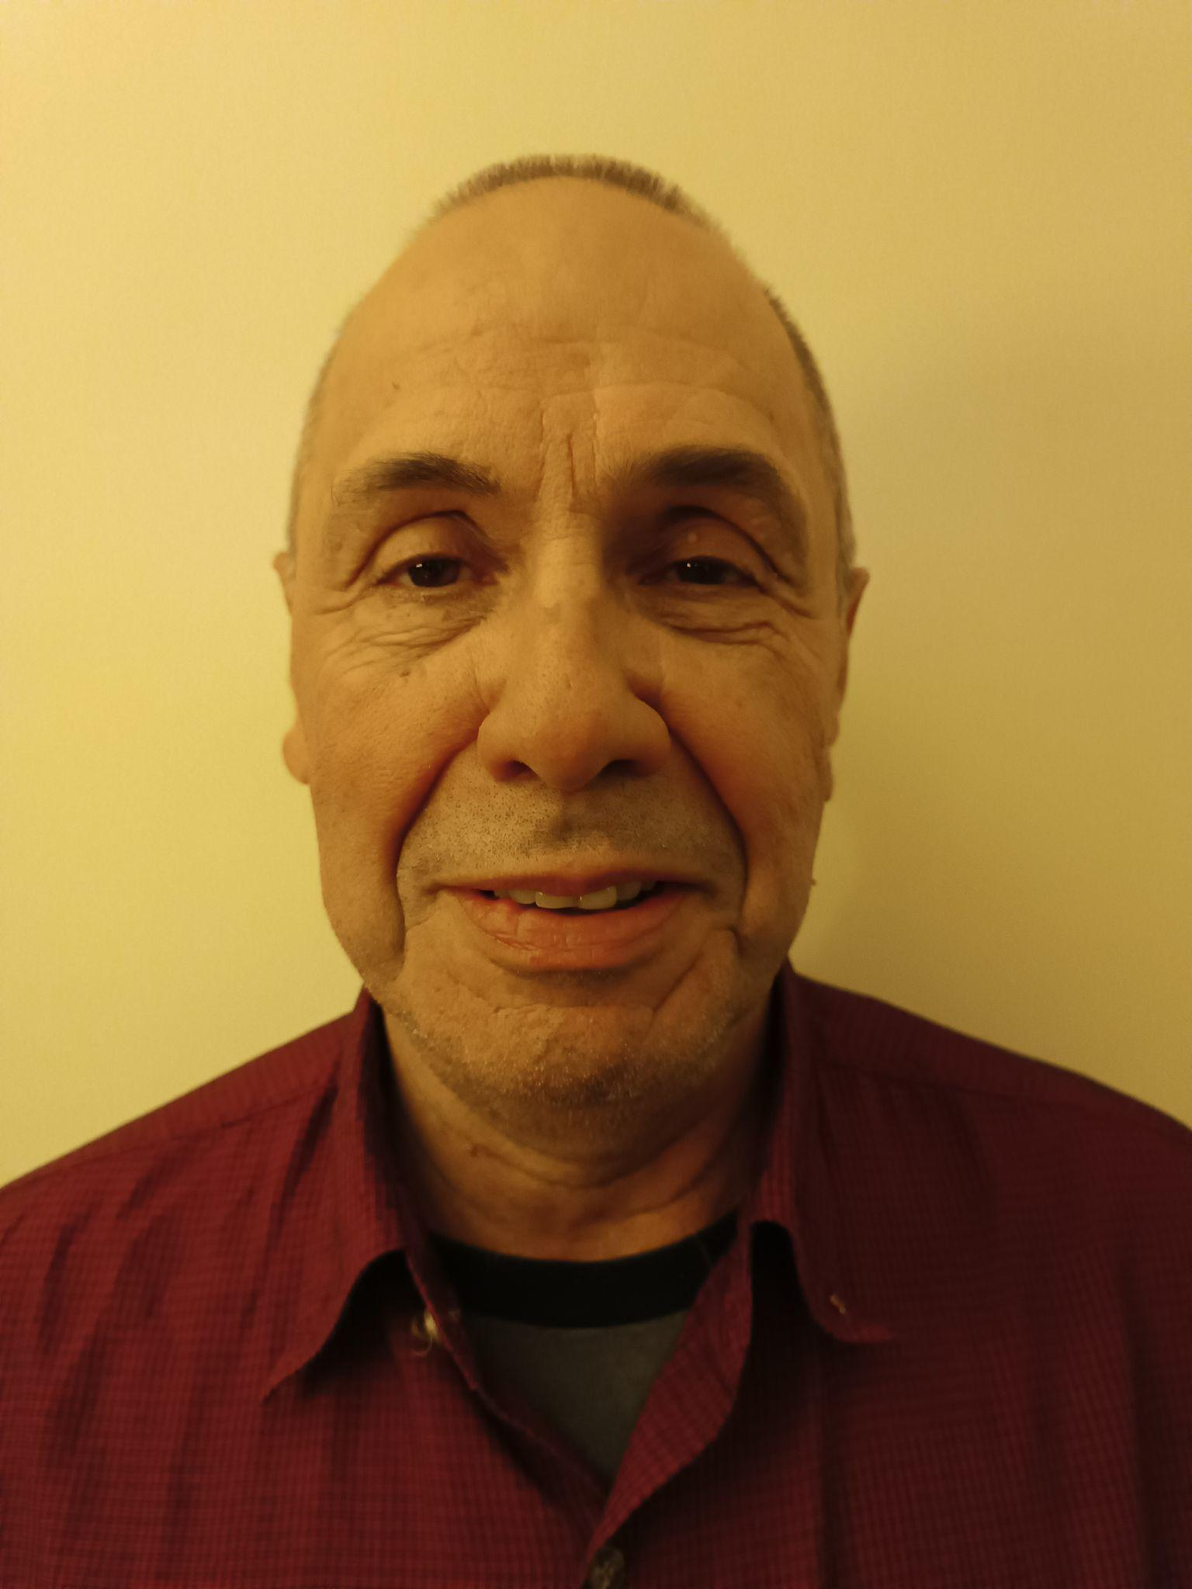
Pam Manias - President  - Bowling since 2016  - Town liaison  - Communications  - House league  - Grounds  - Enjoys sewing, gardening and puzzles | Mary Davidson - Vice President  - Bowling since 2022  - Advertising and Promotion  - Enjoys weight training at the gym, camping, long walks, preparing the monthly in house lunches at the 55+ Club and yoga for relaxation | Bob Penner - Treasurer  - Bowling since 2013  - Finance  - Ladder league  - Drawmaster  - Enjoys travelling, gardening, walking
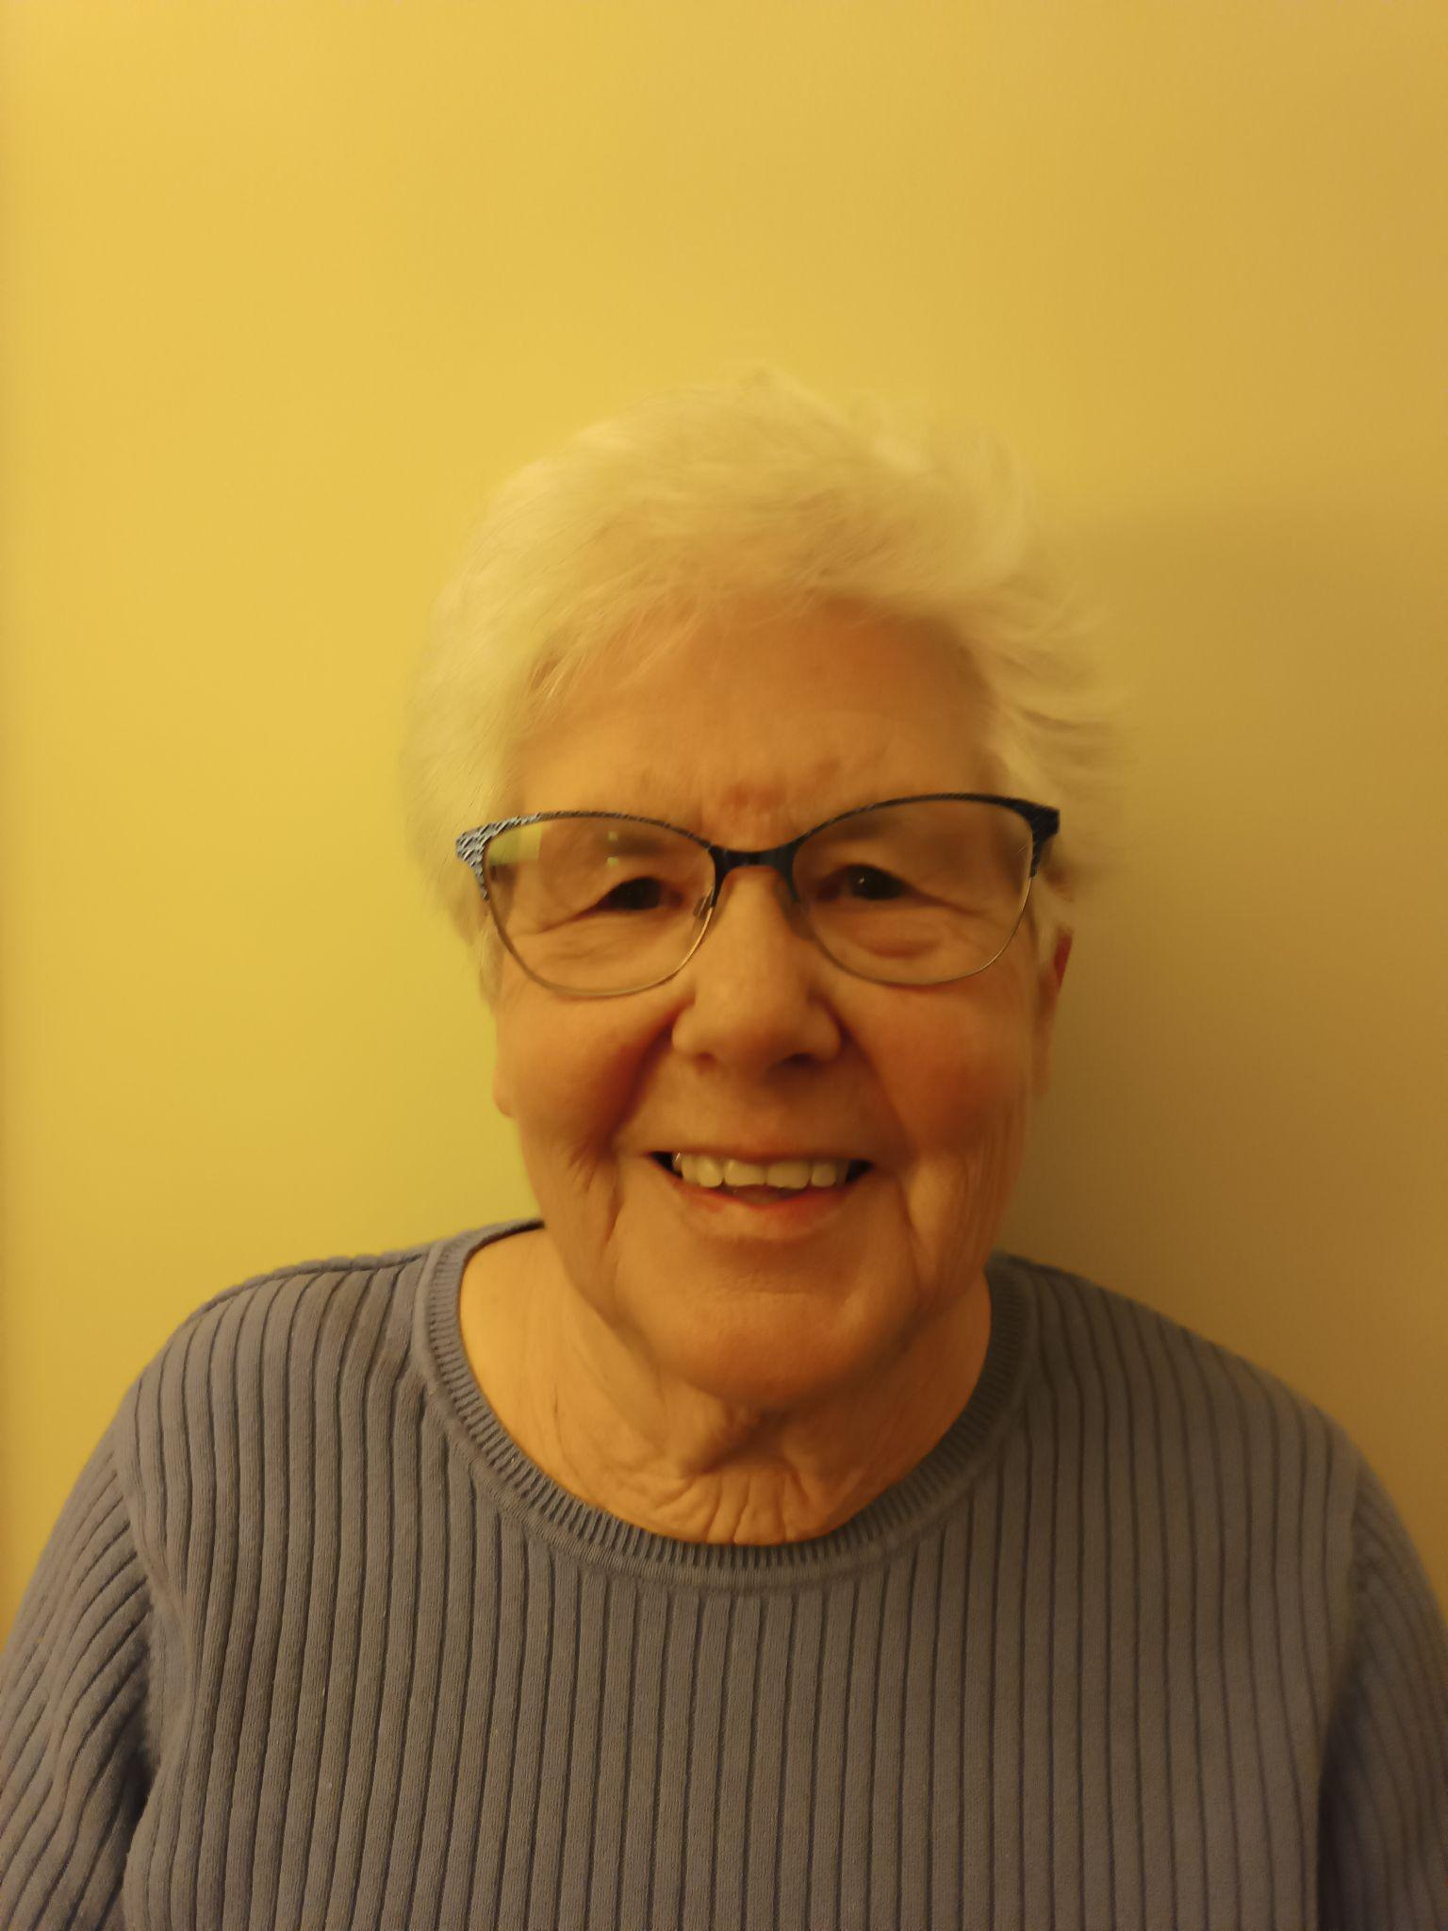
Pat McCarthy - Director  - Bowling since 2013  - Tournaments and Events  - Enjoys reading, gardening and traveling | Tricia Bahen-Secretary  - Bowling since 2022  - Membership and Registration  - Enjoys yoga & pilates  - Enjoys spending time with her grandchildren | - Mike Pyatt..Director  - Bowling since 2023  - Enjoys boating, swimming, golf, walking and spending time at the cottage

April Events
Thursday April 25, 2024 -The Annual General Meeting
This membership meeting will be held at the clubhouse starting at 7pm.
One week prior to the meeting you will receive the Agenda for the meeting,minutes of the Fall AGM 2023, financial report 2023, budget 2024 and revised constitution . The minutes and constitution have to be approved by the membership so please review.
Please try to attend this meeting as we need a quorum of members.
This meeting will be held at the clubhouse at 7pm.
May Events
Monday April 29th-First Registration Evening
Wednesday May 1st-Second Registration Evening
Both evenings will begin at 7pm and our venue is the clubhouse
We ask that if you are coming to register in person, please bring your registration and league forms with you. If possible print the forms from the website Stouffvillelbc.com and bring your forms completed already as space is limited for filling in forms at the clubhouse. However all forms will be available at the Forms Table on the registration nights
Only new members will need to complete the waiver form. Returning 2023 members will pick up their 2023 waiver form from Mary at the separate Waiver Forms Table and sign and date the back of this form. Please then take all completed forms to the Registration Table.
If you cannot attend either of these evenings then of course there is our online registration at Stouffvillelbc.com. Please ensure you complete the registration form, choose your leagues and submit payment by e-transfer to SLBCtreasurer98@gmail.com. Unfortunately we could not provide automatic deposit on our bank account, so your question will be: What is this for?-your answer will be: -SLBC2024 when sending your e-payment. For those that are uncomfortable with e-transfer please drop by and give your payment to Bob Penner, (our 2024 Treasurer) during new bowlers training week /practice week.
Fees this year are $140 returning members, $120 new bowlers, $100 for dual membership, $50 for under 18 and $20 social membership (no bowling but can attend all functions)
May 2, 2024-Drawmaster Clinic
Bob Penner will be hosting a session on learning to become a club Drawmaster. The club really needs club members, who are willing to perform this important (must have) position at one or a few of our 5 open tournaments this summer. It is important that you let Bob know in advance that you will be attending . Please send Bob an email at Bobcpenner@gmail.com
New Bowler Training Week/Practice Week
Monday May 6, Tuesday May 7, Wednesday May 8 and Thursday May 9 evenings from 7pm to 9pm, we will be holding lessons for anyone wishing to try lawn bowling for the first time. Club policy: your first 3 lessons are free with no commitment to join the club. Existing members are encouraged to come help the newbies or come practice after a long winter on these evenings.
Skip/Vice Clinic
Bob Penner will be hosting a clinic on Wednesday May 8th at the clubhouse for all skips and vices. Everyone has their own personal style so come share your perspective.
Monday May 13th to Wednesday May 22nd
These two weeks this year, Monday nights only, we will have jitney bowling. Please note that you must sign up for Monday league at registration in order to play in the Monday night Jitney weeks. Teams will be made up randomly by skips drawing a vice and lead. These 2 weeks will allow new Monday night bowlers to get some experience playing the game before the league begins. This year, we will be encouraging any new bowlers to join Monday night league as leads. Jitney on Monday night will also allow for latecomers to join the club. Our Monday leagues will officially start on Monday May 27th. The balance of the leagues Tuesday morning, Wednesday evening and Thursday morning (if viable) will start the week of May 13th, 2024
Saturday May 4th Open House
Please consider coming to the club for an hour or two to help with an open house designed to bring in new members. Last year’s open house was poorly attended by the public so hopefully this year we will see more interest. Starts around 10am till 3pm (depending on interest)
Bowl and Dine
  - We will have our first Bowl & Dine event on Friday June 7th starting at 4pm. Sandy Iwasiw and myself will be hosting with Sandy sponsoring $250 in prize money.There will be 3 more bowl and dines-Thursday July 4th at 6pm, Tuesday August 13th and finally Friday September 13th our annual George Iwasiw BBQ and crazy games. So we are looking for hosts for the July 4th and August 13th , please let me know if I can count of you. Nominal charge for dinner ($10-$20 set by convenor))
Call for Volunteers
We are always looking for volunteers to help around the club. If you see a “volunteer’s needed” sign up sheet posted on the club white board ,please consider adding your name to the list as “many hands make light work!”
See you all April 25th at 7pm for our annual general meeting
Cheers Pam

